Detection and Segmentation of different structures on planet surface images

Problem Statement

The objective of the project is to segment and label different structures like rocks, craters, etc. on another planet surface. The mission to different planets need route planning and other geological analysis. The rovers to other planets like Mars take lot of videos which generate huge dataset of frames. Manually detecting and segmenting objects in these frames images is not practical. Also route planning need real time detection of objects to help the space ships properly navigate on planet surfaces. Their aim is similar to automated car object detection to avoid collision with rocks on planet surface. The rocks may be of similar color as the background soil and thus segmentation is very difficult.
SVM and CNN could be used to properly segment the images using Machine Learning.

Background

The scientists exploring the solar system planets outside earth need to have good idea of terrain of the planet surface for various prediction of surface formation and other research on planet elements. This data is also needed by rovers on planets which can travel several kilometers in each day and also should not collide with objects in their path. Hence, they have to depend on the images/videos their automated devices can take and predict the rocks and obstacles in their way. Rocks can be identified from their surroundings based on texture difference as color may be same as background. Texture is the image property where objects are differentiated not only on basis of color but also the shape and orientation of object. Image processing shows that properties like entropy and max of GLCM (Gray level Co-occurrence matrix) matrix tells the difference in texture of image parts. The rocks can be of varying shapes and they also have the feature of varying illumination in the direction their surface is inclined by sun light shadow formation.

Methodology

I SVM (Support Vector Machines) are unsupervised way of Machine Learning and are used widely for the object distinguishing from the background. They need histogram of gradients to predict the object in image.

[1] V. Gor et al. introduces a general framework for an automated rock detection process which can be utilized on Mars surface. The process uses unsupervised hierarchical and symmetrical approaches for feature extraction and object recognition and this can be expanded to more diverse data sets. K-means and rule-based segmentation was used by authors to segment large rocks.

[2] David R. Thompson and David Wettergreen describes how the presence of rocks in images can be predicted based on texture, shape and illumination of images using the SVM segmentation of area different from rest of image.

[3] Yonghak Song describes automated rock segmentation on planet images using texture-based image segmentation. Texture based image segmentation is achieved using three schemes: multi-resolution histograms, wavelet based local transform, and inter-scale decision fusion. These results are refined by active contour based on level set method.

II CNN (Convolution Neural Network) approach can be further utilized for solving planet surface objects segmentation and labelling.

[4] Leon F. Palafoxa et al. shows how it can be improved from SVM approach by CNN approach. Training images from previous rover images manually classified into different types of rocks in images can be utilized to train the CNN. This CNN can then predict in new planet explorations to tell the images into one of the class where small rocks are there or class where big rocks are there or class where no rocks are there. As CNN uses convolution in multilayer Neural Network hence it can help the missions greatly by pretrained models to tell the terrain property in run time.

We can use R-CNN (Regional CNN) to predict the objects in images. R-CNN creates bounding boxes around objects, or region proposals, using a process called Selective Search. Selective Search looks at the image through windows of different sizes, and for each size tries to group together adjacent pixels by texture, color, or intensity to identify objects.

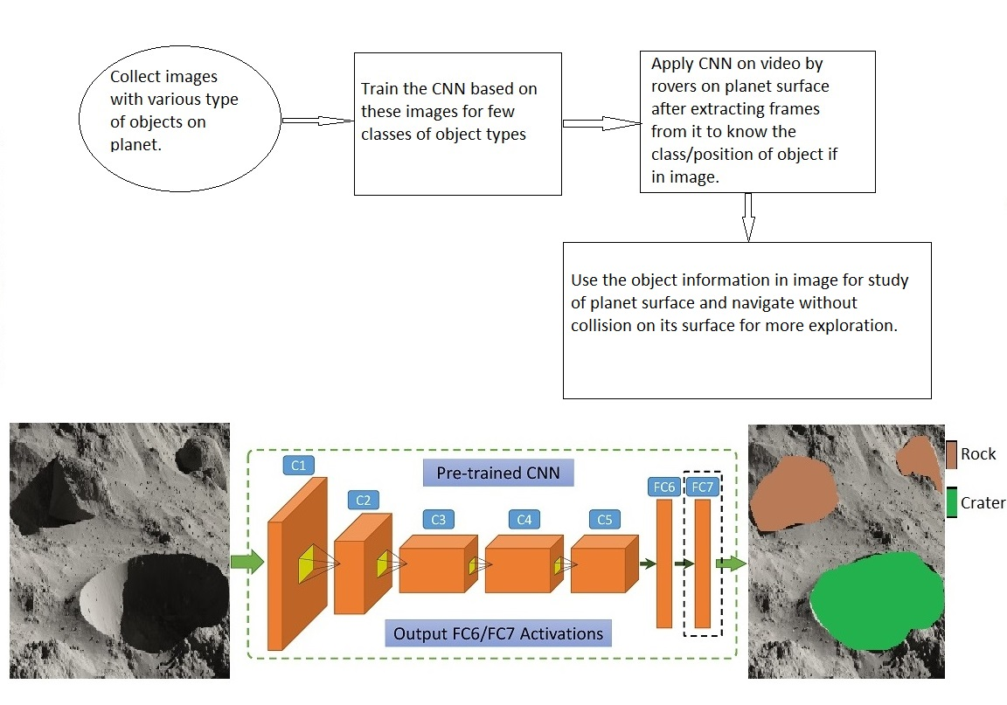

Steps to detect and segment objects on planet surface/R-CNN input and proposed output

Experimental Design

Dataset:

Step1: Images are taken from Mars Dataset from url: https://www.uahirise.org/catalog/

Step 2: Create a CNN with 3-4 classes having images of same type in same class and train using python/tensorflow/keras to make a weights file for giving test image and predicting the class which given image belong to.

Step 3: Use CNN classification and predict the areas different from rest of image and their size and then tell the automatic rover about the size and location of rock/object in its path.

Matlab code with pretrained CNN model can be used from url: https://github.com/leonpalafox/CNNPlanetaryScience

Evaluation Measures:

Measures like false positive and false negatives will be used to know the accuracy of the system. If an object is present and it is not recognized, then it is called false positive. If object is not present and it is predicted, then is false negative.

Software and Hardware Requirements:

Anaconda with spyder is used for CNN which uses python libraries of keras and tensorflow. The hardware needed will be of multi core fast processor or a GPU machine to train on large dataset with epochs more than 40. This will take training time nearly equal to 1 hour. After saving these weights we get a trained model, and this is used to predict new image class.

The CNN can be multi-layer with 3-4 hidden layers and 3 classes or categories with Relu (Rectified Linear Unit) activation function. The loss function used will be adams optimizer and categorial cross entropy. R-CNN method can be incorporated to get the segmentation and labelling process.

References:

[1] Autonomous Rock Detection for Mars Terrain, V. Gor, R. Castano, R. Manduchi, R. C. Anderson, and E. Mjolsness, Copyright © 2001 by the American Institute of Aeronautics and Astronautics

[2] Multi-scale Features for Detection and Segmentation of Rocks in Mars Images, Heather Dunlop, David R. Thompson and David Wettergreen, 1-4244-1180-7/07/$25.00 ©2007 IEEE

[3] Automated Rock Segmentation for Mars Exploration Rover Imagery, Yonghak Song, The International Archives of the Photogrammetry, Remote Sensing and Spatial Information Sciences. Vol. XXXVII. Part B4. Beijing 2008

[4] Automated detection of geological landforms on Mars using Convolutional Neural Networks, Leon F. Palafoxa et al., Computers & Geosciences 101 (2017) 48–56

